**Additional Activities**

During the weekend, other activities including mock crash scene training, fire extinguisher training, brat feeds, spaghetti dinners, pit-bike races, parade laps, charitable fundraisers and the ever-popular Saturday night bonfire keep the activity and fun rolling along all weekend!

**How do you get started?**

First time workers should contact the CRA at: [www.cra-mn.com](http://www.cra-mn.com), calling the CRA hotline at 612-332-4070 and leaving a message stating you want to be a worker or contacting the worker liaison at: [workerliaison@cra-mn.com](mailto:workerliaison@cra-mn.com). To get free admission and camping, you must be added to the worker list no later than one week prior to the event or you will need to pay admission. First time workers that pay admission will be added to the worker list for the next event and get all the freebies associated with being a worker on that weekend. Admission and camping for the full weekend is currently $30.

**Where will you stay?**

BIR has everything from rustic camping sites to full service RV hook-ups to fully furnished, 2 bedroom condominiums to rent. No matter what level of “camping” you prefer, BIR can provide! Additional charges apply for full service RV sites. There are also plenty of hotels in the Brainerd and Baxter areas if you prefer that setting.

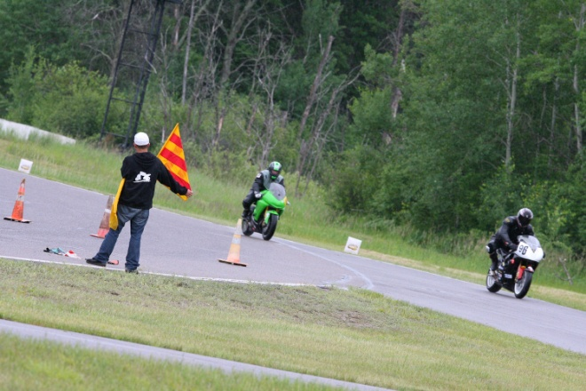

**When is the CRA racing?**

The 2011 race season dates are:

* May 6-7-8
* June 10-11-12
* July 1-2-3
* August 5-6-7
* September 23-24-25



With the CRA,

your weekend is virtually free and fun for all!

**Information compiled and edited by: Dennis Kronberg**

**dennikro@gmail.com**

**Photos courtesy of Momentum Photo**

**www.momentumphoto.net**

**DON’T** Pay to Play!

Being a CRA volunteer is free and so are the benefits! Come and join the Central Roadracing Association at Brainerd International Raceway for a great, free-filled weekend!

**READ ON!**



**Central Roadracing Association**

The CRA was organized more than 40 years ago as a way for motorcycle enthusiasts to satisfy their need for speed in a safe and organized environment. Safety is our 1st priority with good and fair competition our goal. Our “home racetrack” is Brainerd International Raceway (BIR), located 2 hours north of the Twin Cities

The CRA is a unique motorcycle racing organization in that its staff is 100% volunteer…from corner workers to race stewards! The exciting action and fun atmosphere is what keeps our volunteers coming back race after race, year after year.

**Being a volunteer worker is easy!**

You don’t need to personally know anybody in the CRA to get started, you just need to be at least 18 yrs old, have an interest in motorcycles or racing in general and looking to have a great time!



**What do you get out of it?**

* free admission
* free camping
* free lunch each day you work
* a free tee-shirt for the season
* free adult beverages for those 21+ at the Saturday night bonfire
* 1 free guest admission with each worker

Workers also earn points each day they work that go towards CRA gear not available outside of the CRA!

**What’s your commitment?**

You can volunteer as much time as you’d like whether it be a half-day or a whole weekend. Our seasonal events run Fri-Sun once a month, rain or shine.

**What would you do?**

The most recognized and highly-regarded position to work is as a corner worker. Part of the Flagging and Communications group, the corner workers are the backbone of a race weekend. They communicate to the racers via various flags when necessary and act as the eyes and ears of the racetrack for race control.

During an incident (crash, debris on the track, etc), corner workers keep the control tower informed of what’s going on and respond accordingly as directed by the corner captain or control. They may need to move a crashed bike, attend to a rider, direct traffic around an incident, or more.



**How much experience is needed?**

None. Worker training is provided and reviewed every weekend by experienced staff. You will never be expected to do anything you’re unfamiliar or uncomfortable with, without proper instruction and demonstration.

**What should you bring to work an event?**

The CRA runs rain or shine so being prepared for every type of weather is a good idea. We’ve even run in the snow before! Some suggested items include:

* White clothing (Preferred for visibility and to avoid flag colors)
* A small track bag to haul your trackside stuff in
* Sunscreen
* Sunglasses
* Hat or head scarf
* Bug Spray
* Comfortable shoes (no open toes and/or heels...no sandals)
* Work gloves (keep your hands safe when moving motorcycles, etc)
* Chair
* Snacks
* Rain gear

